Android Open Source Project: Core Systems ablet Lockdown Concerning Multiple Manufacturers

The History, Process and Future Directions

Authored by Claire Burn

AOSP On Multiple Manufacturers

The History, Process and Future Directions

Table of Contents

I. Abstract 1

II. Technical Specs 1

III. Introduction & Background Work 1

*i)* *High-Level Requirements* 2

IV. Navigating This Document 3

V. The Process - Overview 3

1) Identify the target Android Tablet that will be the focus of the project. 4

Building & Flashing the HTC AOSP [Current live OS as of 2015] 5

The Process Concerning Tablets From New Manufacturers 6

# Abstract

**Android AOSP is a project to allow the source code of Android to be freely available to developers and companies to adapt, edit, and add to for commercial purposes. It allows the Android platform to be ported to different devices and it will be a great asset in this project. The aim of this project is to port our existing locked down Android OS to a different style and manufacturer of tablet, namely Samsung. The actual manufacturer is arbitrary, the final goal of this project is to create a process for porting the OS to other tablets for future project and possible market expansion into tablet sales.**

# Technical Specs

**Current AOSP**

|  |  |
| --- | --- |
| **Developed By** | Nhan Nguyen |
| **Build System** | Make |
| **Target Device** | Google Nexus Series / HTC |
| **Target Android Version** | Android 4.x |
| **Target Java Version** | Java 7 |
| **Target JDK** | 1.7.x |

**Proposed AOSP**

|  |  |
| --- | --- |
| **Developed By** | Nhan Nguyen / Claire Burn |
| **Build System** | Make |
| **Target Device** | Samsung |
| **Target Android Version** | Android 5+ (Lollipop -> Marshmallow+) |
| **Target Java Version** | Java 7 & 8 |
| **Target JDK** | 1.7 & 1.8 |

# Introduction & Background Work

The Android Tablet device is a secure portable device which allows an inmate to view their messages, movies and pictures and to listen to music via a headset. Inmates can also browse the media catalogue and purchase items via the media app using virtual or real currency.

The current device used by Core (the Google Nexus by HTC) has built-in security features to restrict access to valid users only and has a 30 day timeout feature which is used to disable stolen devices. When the device is connected to the synchronization service either by Wi-Fi or USB, the inmate messages, pictures, media purchases and device catalogue will be updated.

It is critical to prevent the user from accessing the Home Screen (the Android equivalent to the Desktop) and App Launcher. Only specified applications are allowed to run, preventing the user from executing, downloading or installing any other applications. Settings, notifications and other system features are disallowed.

## High-Level Requirements – Initial Stories

* **Device speakers can be disabled.**
* **Wi-Fi can be disabled.**
* **Microphone can be disabled.**
* **Front Camera can be disabled.**
* **Bluetooth is disabled.**
* **Recovery mode is password protected.**
* **Bootloader is locked.**
* **SD card slot (if applicable) can be disabled.**
* **USB ports can be disabled.**

## Functional Requirements

|  |  |
| --- | --- |
|  |  |
| **Create a custom Home Screen/Launcher** | It is critical to prevent the user from accessing the Home Screen (the Android equivalent to the Desktop) and App Launcher. Only specified applications are allowed to run, preventing the user from executing, downloading or installing any other applications. |
| **Custom Lock Screen** | When the tablet screen is locked by the inmate should be possible to see the inmate’s number or booking number on this lock screen, where either a pattern or password is entered to unlock the device. This is important as many tablets could be left in a syncing area and it would make it more difficult for the inmate to locate their tablet in this area. |
| **Landscape Display Only** | The android device should have its orientation locked to Landscape for all apps. |
| **Completely Hide or Disable bottom bar** | Physical buttons should be used in the Core image for device navigation. In newer versions of Android the bottom bar can give access to both the device settings pages and recent apps. |
| **Suppress system notifications windows** | All messages should be communicated to the inmate via the custom launcher application. This gives more control over what is displayed to the inmate. Over Wi-Fi the officer can choose to send the inmate a full screen message at any time. |
| **30 day countdown period** | If the device is not connected within the 30 countdown period the device will be disabled.  A background service will check periodically for this requirement. |
| **Locked down device** | When the device is ‘disabled ‘or ‘locked down’ all functionality will be deactivated and button presses ignored. |
| **Stolen Device** | If a device is reported stolen the device will be locked down the next time it is connected to a kiosk or Wi-Fi. |
| **Countdown Period Reset** | When the device is plugged into the kiosk and it has completed synchronization the countdown period will be reset. If the device is not reported as stolen the login menu will be activated again. |
| **Disable access to Mass Storage Device** | There should be no access to the USB storage on either SD-card or system partitions from a PC. The device data should only be accessible by Core System software. If someone plugs the device into a standard PC the data must be protected. |
| **Restrict users so they can’t install applications themselves** | Do not allow installation of any apps from APKs which are not signed by Core Systems.  Restrict users in the use of installed applications.  Officers can decide whether an individual inmate is allowed to use a particular application. |
| **Block user from changing System Settings** | The user should have no access to the standard android system settings pages. A new user settings application can be run from the custom launcher. This will include the ability to change their screen lock security and view their available balance. |
| **Remote Monitoring** | It is extremely important to remotely monitor the Android device to determine its current status, and allow an audit of the devices. |
| **Custom Image Creation** | Once an image for a device has been locked down and any test inmate data has been removed, a custom rom for that device will be backed up. This rom can then be used to image the rest of the android devices of that type. |
| **Password protected recovery mode** | If the bootloader on the devices are locked it can be ensured that only our custom rom images are loaded onto the Android devices, by password protecting the recovery mode or at least provide some form of a challenge-handshake authentication process. Additionally we could specify that only our signed custom images could be flashed too. |
| **Deactivate the long press Home** | This can give access to recent apps. This might not be a problem but we might want some running apps to remain hidden. |
| **Maintenance Option** | Maintenance options allow you to send the device to sleep and wake it up at specific times. |
| **Peripheral lockdown** | Wi-Fi, Bluetooth, Camera, Auto-Orientation, Flight-mode, Sound. For security reasons inmates should only have access to the hardware that the individual facility allows. It could possibly be more cost effective to provide a tablet device that has no possibility of using a camera on it as it has been disabled at a low level, rather than trying to source an android device with no physical camera on it |
| **Remote Configuration** | Remotely deploy update lockdown configuration via sync service. |
| **Secure Communication** | All communication to and from the device are to be implemented through a secure ADB wrapper client server application. In order for the commands or transfer to be executed, a security token or valid credentials must be passed. |

# Navigating This Document

# Overview of Basic Linux Commands

|  |  |
| --- | --- |
| **cat** | Sends file contents to standard output. This is a way to list the contents of short files to the screen. It works well with piping. Basically outputs the contents of a file to the terminal. |
| **cd** | Change directory. |
| **cp** | Copy files. For example $ cp <path to source file> <path to destination> |
| **dd** | Disk duplicate. The man page says this command is to "Convert and copy a file", but although used by more advanced users, it can be a very handy command. The "if" means input file, "of" means output file. |
| **df** | Show the amount of disk space used on each mounted filesystem. |
| **less** | Similar to the cat command, but the user can page up and down through the file. Displays the contents of textfile. |
| **locate** | A fast database driven file locator. Locates files within the filesystem if given a filename. |
| **logout** | Logs the current user off the system. |
| **ls** | List files in the current directory. |
| **mv** | Move or rename files; syntax is $ mv <source> <destination> |
| **pwd** | Show the name of the current working directory |
| **shutdown** | Shuts the system down. |
| **tar –zxvf <tarball name>** | Extracts files from a compressed package. Similar to zip files. |
| **apt-get install** | Installs packages from the agreed repository dependent on the flavour of Linux being used. |
|  |  |

### TIPS:

|  |
| --- |
| * Anything in this document with a ‘ $ ‘ before it indicates a command that should be input into the Linux terminal. * The text editor used for examples in this document is Vim (Vi Improved). If you do not have it, get it on your Linux system by typing: $ sudo apt-get install vim.     **Note:** .sh files are executable shell files called scripts (usually BASH). You can run these by typing ./ before the name of the script. E.g. if you have a BASH script named build_kernel.sh, it would be executed like so:  $ ./build_kernel.sh |

# The Process - Overview

* **Identify the target Android Tablet that will be the focus of the project.**
* **Set up host PC for compilation.**
* **Acquire the kernel source code for the target manufacturer.**
* **Determine requirements for the end product.**
* **Compile kernel with features enabled/disabled.**
* **Root Device and Flash new image.**

# Known Issues Encountered

* When downloading the Samsung source code, when the model number (the first 5 digits seems to be optimal, but again this is educated guessing) is entered into the search of the Samsung Open Source Resource Centre, several versions of source code appear. I am not entirely sure how to determine which version of source code to download in this instance, and there does not seem to be any adequate documentation on it. I asked Stack Overflow, RootzWiki and the Samsung Open Source Resource Centre themselves, with no adequate answer.
* I could not locate the Android Debug Bridge (adb) source code within the Samsung source for the SM-T555, and so the adb functionality may be limited.

# Process Walkthrough

## Identify the target Android Tablet that will be the focus of the project.

It is important to know the hardware for which you will be compiling a custom kernel. This will have a knock on effect on everything else that is done during the process of loading the locked down Android OS. It is useful to locate several pieces of information on the hardware:

* The serial number of the device
* The manufacturer
* The model number
* Baseband version

|  |  |  |
| --- | --- | --- |
| **Data Point** | **Format** | **Explanation** |
| Serial Number of the Device (also called an International Mobile Equipment Identity (IMEI)) | 15-digit unique number | Settings > About Device > Status > IMEI. This is a uniquely identifiable number for your tablet. |
| Manufacturer | A name i.e. Samsung | This will heavily influence where you download your source code from, and which drivers you include within your final image, as these vary by manufacturer. |
| Model Number | [With Samsung] Two letters, then a string of 10/11 variable letters/digits. E.g. SM-T810NZKEDBT | IMPORTANT: For Galaxy Tab, enter the first 6 digits/letters of the model number into the search box when searching for an open source download. |
| Baseband version | A three letter code e.g. LFB | Baseband, controls cellular reception and some aspects of WiFi. Think of it as your radio. You can access the current version in Settings/About Device > Tablet. |

## Set up Host PC for compilation.

**Hardware requirements**

Your development workstation should meet or exceed these hardware requirements:

* A 64-bit environment is required.
* At least 100GB of free disk space for a checkout of AOSP or the expansion of the source on a Linux machine, 150GB for a single build, and 200GB or more for multiple builds. If you employ ccache, you will need even more space.
* A Linux in a virtual machine will need at least 16GB of RAM/swap.

**Software requirements**

You workstation must have the software listed below.

**Operating system**

Android is typically built with a Linux or Mac OS operating system. It is also possible to build Android in a virtual machine on unsupported systems such as Windows, however this is not recommended.

**Linux – Minimum Requirements**

* For building for Android 6.0 (Marshmallow) - Ubuntu 14.04 or newer.
* For building for Android 5.x (Lollipop): Ubuntu 12.04 or newer.

**Java Development Kit (JDK)**

Please note, since there are no available supported OpenJDK 8 packages for Ubuntu 14.04, the Ubuntu 15.04 packages must be installed manually. See [JDK for Ubuntu LTS 14.04](https://source.android.com/source/initializing.html#for-ubuntu-14-04) for precise instructions.

* For building for Android 5.x (Lollipop) & Android 6.0 (Marshmallow): Ubuntu - Java JDK 7

**Other Key Packages**

* Python 2.6 or newer from [python.org](http://www.python.org/download/) (do NOT use Python 3)

$ apt-get install python2.7

* GNU Make 3.81 or newer from [gnu.org](http://ftp.gnu.org/gnu/make/).

$ apt-get install make

* Git 1.7 or newer from [git-scm.com](http://git-scm.com/download)

$ apt-get install git

To check if a program is already installed type the program name followed by --version or -v

**Setting up a Linux build environment**

**Installing the JDK For Ubuntu LTS 14.04+**

Run the following:

$ sudo apt-get update  
# cd /opt/

# wget --no-cookies --no-check-certificate --header "Cookie: gpw_e24=http%3A%2F%2Fwww.oracle.com%2F; oraclelicense=accept-securebackup-cookie" "http://download.oracle.com/otn-pub/java/jdk/7u79-b15/jdk-7u79-linux-x64.tar.gz"

# tar xzf jdk-7u79-linux-x64.tar.gz

There are no available supported OpenJDK 8 packages for Ubuntu 14.04. The **Ubuntu 15.04 OpenJDK 8**packages have been used successfully with Ubuntu 14.04. *Newer package versions (e.g. those for 15.10, 16.04) were found not to work on 14.04 using the instructions below.*

1. Download the .deb packages for your architecture from <http://packages.ubuntu.com/vivid/openjdk-8-jdk>:
   * [openjdk-8-jre-headless](http://packages.ubuntu.com/vivid/openjdk-8-jre-headless)
   * [openjdk-8-jre](http://packages.ubuntu.com/vivid/openjdk-8-jre)
   * [openjdk-8-jdk](http://packages.ubuntu.com/vivid/openjdk-8-jdk)

Remember, you may obtain the architecture for your machine with:

$ uname -m

With x86_64 representing a 64-bit (amd64) Linux kernel architecture and i386/i486/i586/i686 representing a 32-bit (i386) system.

1. Optionally, confirm the checksums of the downloaded files using the information found on<http://packages.ubuntu.com/vivid/openjdk-8-jdk>.

For example with the sha256sum tool:

$ sha256sum {package file}

1. Install the packages:

$ sudo apt-get update

Run dpkg for each of the .deb files you downloaded. It may produce errors due to missing dependencies:

$ sudo dpkg -i {downloaded.deb file}

To fix missing dependencies:

$ sudo apt-get -f install

Update the default Java version - optional

Optionally, for the Ubuntu versions above update the default Java version by running:

$ sudo update-alternatives --config java  
$ sudo update-alternatives --config javac

If, during a build, you encounter version errors for Java, set its path as described in the [Wrong Java Version](https://source.android.com/source/building.html#wrong-java-version)section.

To develop older versions of Android, download and install the corresponding version of the [Java JDK](http://www.oracle.com/technetwork/java/javase/archive-139210.html):  
Java 7: for Lollipop through Marshmallow  
Java 6: for Gingerbread through KitKat  
Java 5: for Cupcake through Froyo

Installing required packages (Ubuntu 14.04)

You will need a 64-bit version of Ubuntu. Ubuntu 14.04 is recommended.

$ sudo apt-get install git-core gnupg flex bison gperf build-essential \  
  zip curl zlib1g-dev gcc-multilib g++-multilib libc6-dev-i386 \  
  lib32ncurses5-dev x11proto-core-dev libx11-dev lib32z-dev ccache \  
  libgl1-mesa-dev libxml2-utils xsltproc unzip

**Note:** To use SELinux tools for policy analysis, also install the python-networkx package.

Installing required packages (Ubuntu 12.04)

You may use Ubuntu 12.04 to build older versions of Android. Version 12.04 is not supported on master or recent releases.

$ sudo apt-get install git gnupg flex bison gperf build-essential \  
  zip curl libc6-dev libncurses5-dev:i386 x11proto-core-dev \  
  libx11-dev:i386 libreadline6-dev:i386 libgl1-mesa-glx:i386 \  
  libgl1-mesa-dev g++-multilib mingw32 tofrodos \  
  python-markdown libxml2-utils xsltproc zlib1g-dev:i386  
$ sudo ln -s /usr/lib/i386-linux-gnu/mesa/libGL.so.1 /usr/lib/i386-linux-gnu/libGL.so

Installing required packages (Ubuntu 10.04 -- 11.10)

Building on Ubuntu 10.04-11.10 is no longer supported, but may be useful for building older releases of AOSP.

$ sudo apt-get install git gnupg flex bison gperf build-essential \  
  zip curl zlib1g-dev libc6-dev lib32ncurses5-dev ia32-libs \  
  x11proto-core-dev libx11-dev lib32readline5-dev lib32z-dev \  
  libgl1-mesa-dev g++-multilib mingw32 tofrodos python-markdown \  
  libxml2-utils xsltproc

On Ubuntu 10.10:

$ sudo ln -s /usr/lib32/mesa/libGL.so.1 /usr/lib32/mesa/libGL.so

On Ubuntu 11.10:

$ sudo apt-get install libx11-dev:i386

Configuring USB Access

Under GNU/Linux systems (and specifically under Ubuntu systems), regular users can't directly access USB devices by default. The system needs to be configured to allow such access.

The recommended approach is to create a file at /etc/udev/rules.d/51-android.rules (as the root user).

To do this, run the following command to download the [51-android.rules](https://source.android.com/source/51-android.rules) file attached to this site, modify it to include your username, and place it in the correct location:

$ wget -S -O - http://source.android.com/source/51-android.rules | sed "s/<username>/$USER/" | sudo tee >/dev/null /etc/udev/rules.d/51-android.rules; sudo udevadm control --reload-rules

Those new rules take effect the next time a device is plugged in. It might therefore be necessary to unplug the device and plug it back into the computer.

This is known to work on both Ubuntu Hardy Heron (8.04.x LTS) and Lucid Lynx (10.04.x LTS). Other versions of Ubuntu or other variants of GNU/Linux might require different configurations.

Using a separate output directory

By default, the output of each build is stored in the out/ subdirectory of the matching source tree.

On some machines with multiple storage devices, builds are faster when storing the source files and the output on separate volumes. For additional performance, the output can be stored on a filesystem optimized for speed instead of crash robustness, since all files can be re-generated in case of filesystem corruption.

To set this up, export the OUT_DIR_COMMON_BASE variable to point to the location where your output directories will be stored.

export OUT_DIR_COMMON_BASE=<path-to-your-out-directory>

The output directory for each separate source tree will be named after the directory holding the source tree.

For instance, if you have source trees as /source/master1 and /source/master2 and OUT_DIR_COMMON_BASE is set to /output, the output directories will be /output/master1 and /output/master2.

It's important in that case to not have multiple source trees stored in directories that have the same name, as those would end up sharing an output directory, with unpredictable results.

This is only supported on Jelly Bean (4.1) and newer, including the master branch.

Setting up a Mac OS build environment

In a default installation, Mac OS runs on a case-preserving but case-insensitive filesystem. This type of filesystem is not supported by git and will cause some git commands (such as git status) to behave abnormally. Because of this, we recommend that you always work with the AOSP source files on a case-sensitive filesystem. This can be done fairly easily using a disk image, discussed below.

Once the proper filesystem is available, building the master branch in a modern Mac OS environment is very straightforward. Earlier branches, including ICS, require some additional tools and SDKs.

Creating a case-sensitive disk image

You can create a case-sensitive filesystem within your existing Mac OS environment using a disk image. To create the image, launch Disk Utility and select "New Image". A size of 25GB is the minimum to complete the build; larger numbers are more future-proof. Using sparse images saves space while allowing to grow later as the need arises. Be sure to select "case sensitive, journaled" as the volume format.

You can also create it from a shell with the following command:

# hdiutil create -type SPARSE -fs 'Case-sensitive Journaled HFS+' -size 40g ~/android.dmg

This will create a .dmg (or possibly a .dmg.sparseimage) file which, once mounted, acts as a drive with the required formatting for Android development.

If you need a larger volume later, you can also resize the sparse image with the following command:

# hdiutil resize -size <new-size-you-want>g ~/android.dmg.sparseimage

For a disk image named android.dmg stored in your home directory, you can add helper functions to your~/.bash_profile:

* To mount the image when you execute mountAndroid:

# mount the android file image  
function mountAndroid { hdiutil attach ~/android.dmg -mountpoint /Volumes/android; }

**Note:** If your system created a .dmg.sparseimage file, replace ~/android.dmg with~/android.dmg.sparseimage.

* To unmount it when you execute umountAndroid:

# unmount the android file image  
function umountAndroid() { hdiutil detach /Volumes/android; }

Once you've mounted the android volume, you'll do all your work there. You can eject it (unmount it) just like you would with an external drive.

Installing the JDK

See [Requirements](https://source.android.com/source/requirements.html) for the version of Java to use when developing various versions of Android.

Installing required packages

* Install Xcode from [the Apple developer site](http://developer.apple.com/). If you are not already registered as an Apple developer, you will have to create an Apple ID in order to download.
* Install MacPorts from [macports.org](http://www.macports.org/install.php).

**Note:** Make sure that /opt/local/bin appears in your path **before** /usr/bin. If not, please add the following to your ~/.bash_profile file:

export PATH=/opt/local/bin:$PATH

**Note:** If you do not have a .bash_profile file in your home directory, create one.

* Get make, git, and GPG packages from MacPorts:

$ POSIXLY_CORRECT=1 sudo port install gmake libsdl git gnupg

If using Mac OS X v10.4, also install bison:

$ POSIXLY_CORRECT=1 sudo port install bison

Reverting from make 3.82

In Android 4.0.x (Ice Cream Sandwich) and earlier, a bug exists in gmake 3.82 that prevents android from building. You can install version 3.81 using MacPorts with these steps:

* Edit /opt/local/etc/macports/sources.conf and add a line that says

file:///Users/Shared/dports

above the rsync line. Then create this directory:

$ mkdir /Users/Shared/dports

* In the new dports directory, run

$ svn co --revision 50980 http://svn.macports.org/repository/macports/trunk/dports/devel/gmake/ devel/gmake/

* Create a port index for your new local repository:

$ portindex /Users/Shared/dports

* Finally, install the old version of gmake with

$ sudo port install gmake @3.81

Setting a file descriptor limit

On Mac OS, the default limit on the number of simultaneous file descriptors open is too low and a highly parallel build process may exceed this limit.

To increase the cap, add the following lines to your ~/.bash_profile:

# set the number of open files to be 1024  
ulimit -S -n 1024

sudo apt-get install liblz4-tool

## Acquire the kernel source for the target manufacturer

You will need 3 things for this stage:

* The kernel. Kernel source code is under GNU GPL open source license so vendors (e.g. Sony, HTC, Samsung, LG) have to release it. You can find your appropriate kernel source code from mentioned websites:
  + For Sony: <http://developer.sonymobile.com/>
  + For Samsung: <http://opensource.samsung.com/>
  + For HTC: <http://www.htcdev.com/>
  + For LG: <http://www.lg.com/global/support/opensource/index>
* The toolchain for compiling the kernel and cross-compiling. There are several ways to ascertain which toolchain is needed. Firstly, look in ‘README_Kernel.txt’ which will be located within the downloaded source code for Samsung devices. If a toolchain is available and downloaded already, it may be in /prebuilts/gcc/linux-x86/arm/, or look at <https://android.googlesource.com/platform/prebuilts/gcc/linux-x86/arm/> for a list of all available toolchains. The README_Kernel.txt file should specify which version to use.

### Knowing Which Source To Download – POC for Samsung Source

First, locate the model number of the tablet that has been acquired. The model number should have a format of “SM-YYYY” where Y is a digit of some description. E.g. SM-T555. Model numbers can also be found on Amazon when purchasing the tablets, or if the make of the tablet is known, by simply Googling this. Navigate to <http://opensource.samsung.com/reception.do> and enter the model number in the search space. If no results are returned, try shortening the model number, and if this still returns no results, then there is no open source code available for the specific model of Samsung tablet; but this should not be the case.

Ignore the fact that the ‘Classification’ field says ‘Mobile Phone’; this is a mistake on Samsung’s part. A few results may be returned. If this is the case, locate the first open source instance with the literal letters “XX” “XW” or “XA” somewhere in the “Version” field string (but most likely “XX”). The format of the Version field should be “YYYYXXxxxxxx” where Y is the last four characters of the model number, followed by two ‘X’s followed by a further six character code which represents the build version. The two ‘X’s symbolise the region, which in this case is Europe.

Click on the Source Code link and download the .zip file. This should all be done on your Linux Box to avoid complications.



**Decompressing the Kernel Tarball**

Within the downloaded source (once you’ve unzipped it), there should be a file called ‘Kernel.tar.gz’.

|  |  |
| --- | --- |
| Create a new directory to extract the kernel to: | $ mkdir kernel |
| Extract the kernel: | $ tar –zxvf Kernel.tar.gz –C kernel |
| Change directory to where the kernel is located: | $ cd kernel/ |

This process is exactly the same for the other .tar.gz files within the original zip file. E.g. Platform.tar.gz.

**Setting up the toolchain**

* This toolchain is only used to build the kernel.
* This toolchain may or may not be included in the Android source package. ($ANDROID_ROOT/prebuilts/gcc/linux-x86/arm/arm-eabi-4.*)

Within the downloaded source code there should be a file named README_Kernel.txt. Open this in your text editor of choice and follow the instructions inside. For example:

###########################################################################

1. How to Build

- get Toolchain

From android git server , codesourcery and etc ..

- arm-eabi-4.8

- edit Makefile

edit "CROSS_COMPILE" to right toolchain path(You downloaded).

EX) export CROSS_COMPILE= $(android platform directory you download)/android/gcc/prebuilts/linux-x86/arm/arm-eabi-4.8/bin/arm-eabi-

Ex) export CROSS_COMPILE=/usr/local/toolchain/arm-eabi-4.8/bin/arm-eabi- // check the location of toolchain

$ export CROSS_COMPILE=(compiler path)

$ export ARCH=arm

$ mkdir output

$ make -C $(pwd) O=output msm8916_sec_defconfig VARIANT_DEFCONFIG=msm8916_sec_gt510wifi_eur_defconfig SELINUX_DEFCONFIG=selinux_defconfig

$ make -C $(pwd) O=output

$ cp output/arch/arm/boot/zImage arch/arm/boot/zImage

2. Output filesS

- Kernel : output/arch/arm/boot/zImage

- module : output/drivers/*/*.ko

3. How to Clean

$ cd output

$ make clean

################################################################################

*This is an example of what may be in the README_Kernel file.*

In this instance, the version of the toolchain required is arm-eabi-4.8. This can be seen in the How To Build section of the above text.

TOOLCHAINS CAN BE DOWNLOADED HERE:

<https://android.googlesource.com/platform/prebuilts/gcc/linux-x86/arm/>

## Toolchain – Step by Step

**\*\*\* 28/04/16 C.B.** – I have created a script to automatically ascertain the required toolchain version and download & install it. It is named get_toolchain in the git repository I have left at and needs to be placed in the same directory as the README_Kernel.txt file. Then run the following commands. ***

BEFORE YOU RUN THE SCRIPT, SKIP TO THE ‘BUILDING THE KERNEL’ SECTION OF THIS DOC AND FOLLOW THE INSTRUCTIONS.

$ chmod 777 get_toolchain

$ ./get_toolchain

**Step 1 – Make sure you have a bashrc**

Make sure that you have a bashrc file by typing the following and ensuring that something comes up when this command is run:

$ ls -la ~ | grep .bashrc

The bashrc file is a file full of environment settings for Linux. You will need to add to this later. If nothing is returned when that command is run, create a bashrc by:

$ cd ~

$ sudo cp /etc/skel/.bashrc .

OR

$ touch ~/.bashrc

#### **Step 2 – Ensure that the kernel does not build…… yet.**

Run the script ‘build_kernel_test.sh’ by navigating to the folder where the script exists (it should just be in extracted kernel directory), and typing:

$ ./build_kernel_test.sh

If there is an error involving the location of the toolchain, or if the Makefile (this will come up as a ‘make’ or ‘sub make’ error) is looking for a different version of the toolchain, simply download the appropriate version from <https://android.googlesource.com/platform/prebuilts/gcc/linux-x86/arm/> and continue with this guide. However, make sure to actually read the error message that comes back; the kernel always will tell the user what the problem is. The lines that are important are usually prefixed with the term ‘Error:’.

**Step 3 - Copy the cross compiling tool package to /opt/toolchains**

**Either Do:**

If the '/opt/toolchains' directory does not exist in host pc, then create the directory by doing the following:

$ sudo mkdir /opt/toolchains

Then, copy the downloaded toolchain code to this newly created directory and navigate to it:

$ sudo cp arm-eabi-4.8.tar.gz /opt/toolchains

$ cd /opt/toolchains

#### Decompress the cross tool with tar command

$ cd /opt/toolchains

$ sudo tar -xvf arm-eabi-4.8.tar.gz

If you had already decompressed the tar file, the commands are simply as follows:

$ sudo mkdir /opt/toolchains

$ sudo cp –r arm-eabi-4.8 /opt/toolchains

#### Add the cross compiler to the Path in your environment file by modifying your ~/.bashrc file to add a new path with your text editor of choice. Simply add these lines at the end of the file.

$ export ARCH=arm

$ export PATH=${PATH}:/opt/toolchains/arm-eabi-4.8/bin

$ export CROSS_COMPILE=arm-eabi-

To apply this change, login again or restart the .bashrc

$ source ~/.bashrc

**OR THIS:**

Assuming you don't have a toolchain downloaded already, you can download it by running the following commands:

git clone https://android.googlesource.com/platform/prebuilts/gcc/linux-x86/arm/arm-eabi-4.8 toolchain

export ARCH=arm

export SUBARCH=arm

export CROSS_COMPILE=`pwd`/toolchain/bin/arm-eabi-

For 64 bit devices (using Marshmallow (not applicable for our use case, but perhaps in future)), use the appropriate toolchain:

git clone https://android.googlesource.com/platform/prebuilts/gcc/linux-x86/aarch64/aarch64-linux-android-4.9 -b marshmallow-release toolchain64

export ARCH=arm64

export SUBARCH=arm64

export CROSS_COMPILE=`pwd`/toolchain64/bin/aarch64-linux-android-

**Step 4 – Check the toolchain is set up properly**

#### Check the tool-chain path to see if it is set up correctly or not by typing the following.

$ arm-eabi-gcc -v

This should give a result of something similar to the below code if it is set up correctly:

Using built-in specs.

COLLECT_GCC=arm-eabi-gcc

COLLECT_LTO_WRAPPER=/opt/toolchains/arm-eabi-4.8/bin/../libexec/gcc/arm-eabi/4.8/lto-wrapper

Target: arm-eabi

Configured with: /tmp/AOSP-toolchain/build/../gcc/gcc-4.8/configure --prefix=/tmp/toolchain-build-eabi/prefix --target=arm-eabi --host=x86_64-linux-gnu --build=x86_64-linux-gnu --with-gnu-as --with-gnu-ld --enable-languages=c,c++ --with-gmp=/tmp/toolchain-build-eabi/temp-install --with-mpfr=/tmp/toolchain-build-eabi/temp-install --with-mpc=/tmp/toolchain-build-eabi/temp-install --with-cloog=/tmp/toolchain-build-eabi/temp-install --with-isl=/tmp/toolchain-build-eabi/temp-install --with-ppl=/tmp/toolchain-build-eabi/temp-install --disable-ppl-version-check --disable-cloog-version-check --disable-isl-version-check --enable-cloog-backend=isl --with-host-libstdcxx='-static-libgcc -Wl,-Bstatic,-lstdc++,-Bdynamic -lm' --disable-libssp --enable-threads --disable-nls --disable-libmudflap --disable-libgomp --disable-libstdc__-v3 --disable-sjlj-exceptions --disable-shared --disable-tls --disable-libitm --with-float=soft --with-fpu=vfp --with-arch=armv5te --enable-target-optspace --with-abi=aapcs --enable-initfini-array --disable-nls --prefix=/tmp/toolchain-build-eabi/prefix --with-sysroot=/tmp/toolchain-build-eabi/prefix/sysroot --with-binutils-version=2.23 --with-mpfr-version=3.1.1 --with-mpc-version=1.0.1 --with-gmp-version=5.0.5 --with-gcc-version=4.8 --with-gdb-version=7.6 --with-gxx-include-dir=/tmp/toolchain-build-eabi/prefix/include/c++/4.8 --with-bugurl=http://source.android.com/source/report-bugs.html --disable-bootstrap --disable-libquadmath --enable-plugins --enable-libgomp --disable-libsanitizer --enable-gold --enable-graphite=yes --with-cloog-version=0.18.0 --with-isl-version=0.11.1 --enable-eh-frame-hdr-for-static --with-arch=armv5te --disable-gold --disable-libgomp --program-transform-name='s&^&arm-eabi-&'

Thread model: single

gcc version 4.8 (GCC)

<https://source.android.com/source/building-kernels.html>

## Building The Kernel

If building manually (i.e. not using the ‘get_toolchain’ script provided), make sure that the following instructions are adhered to:

$ vim build_kernel.sh

In this file, delete the text SELINUX_DEFCONFIG=selinux_defconfig , but nothing else.

From the root directory of the Samsung source, do:

$ cd arch/arm/configs/

edit ./arch/arm64/configs/flounder_defconfig set CONFIG_SECURITY_SELINUX=n

add this is if not there

Go to build_kernel delete SELinux=x

CONFIG_USB_DEBUG=y

Volume up & home button & power button when tab is powered down

(STILL WORKING ON THIS BIT).

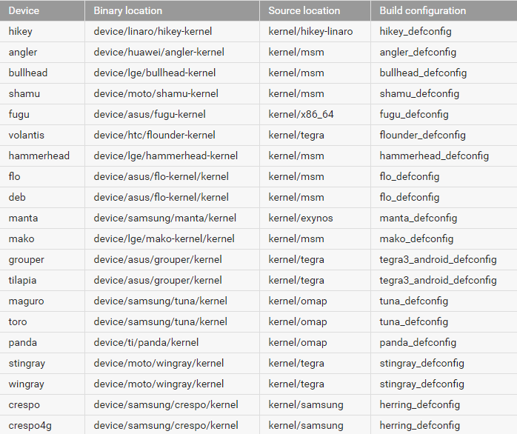

If we are focusing on Samsung devices, here are the codenames and the devices they equate to:

|  |  |  |
| --- | --- | --- |
| **Codename** | **Device** | **Source** |
| Manta | Google Nexus 10 | https://android.googlesource.com/device/samsung/manta/ |
| Tuna (Maguro)  [GSM Version] | Samsung Galaxy Nexus | https://android.googlesource.com/device/samsung/tuna/ |
| Tuna (Toro)  [CDMA Version] | Samsung Galaxy Nexus | https://android.googlesource.com/device/samsung/tuna/ |
| Crespo | Samsung Nexus S | https://android.googlesource.com/device/samsung/crespo/ |
|  |  |  |

## BUILDING THE CURRENT NEXUS AOSP

**\*\* Core will provide you with a CoreTablets.zip file, it is important that you extract the CoreTablets folder inside the zip onto your C:\ drive** **as shown below**:

**Important initial steps:**  
Located on your computer C:\user\name there will be a .android folder, please take the two adbkey files from here:  
**C:\CoreTablets\ADBKEY & Google Nexus Drivers** and drop them into here:  
**C:\Users\YourNameHere\.android**When you plug the device into the computer initially you may need to install the google nexus drivers in order to be able to communicate with them, you can do this via windows “**Device Manager**”, if you are missing the driver you will see an “Android” entry here, simply right click and update the device driver, point it to the following folder:  
**C:\CoreTablets\ADBKEY & Google Nexus Drivers\Google USB Nexus driver**

# Flashing from Android to Core

When you buy a brand new Android tablet it comes pre-installed with the Android operating system - the equivalent of Windows on your computer. To use the Direct2inmate software on a new tablet you need to override the Android operating system with the Core specific operating system. This means that anyone using this tablet will only be able to use the Direct2inmate software.

Steps:

## Power on the tablet

* 1. Press and hold the power button on the side of the tablet, above the volume buttons.

You should see a Google logo appear in the middle of a black screen.

## Setup tablet for first use

* 1. Select language on the Welcome screen.
  2. Once you have selected the language you want, tap the button below.
  3. Select a Wifi network.
  4. Enter password for selected Wi-Fi and tap “Next”.
  5. Once you have connected to Wi-Fi, continue to tap Next and / or Skip until you reach the “Setup Complete” screen.
  6. Tap Finish

## Enable Developer options

* 1. Tap the Menu icon on the Home screen.

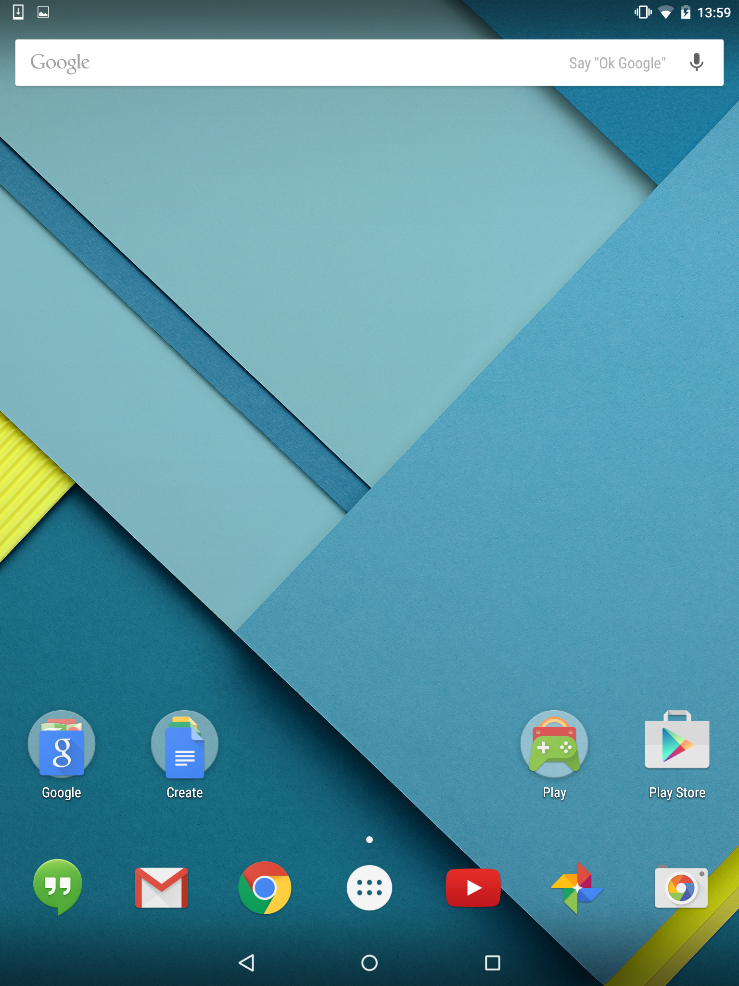

*Menu icon*

* 1. Tap the Settings icon within the menu (shown below).

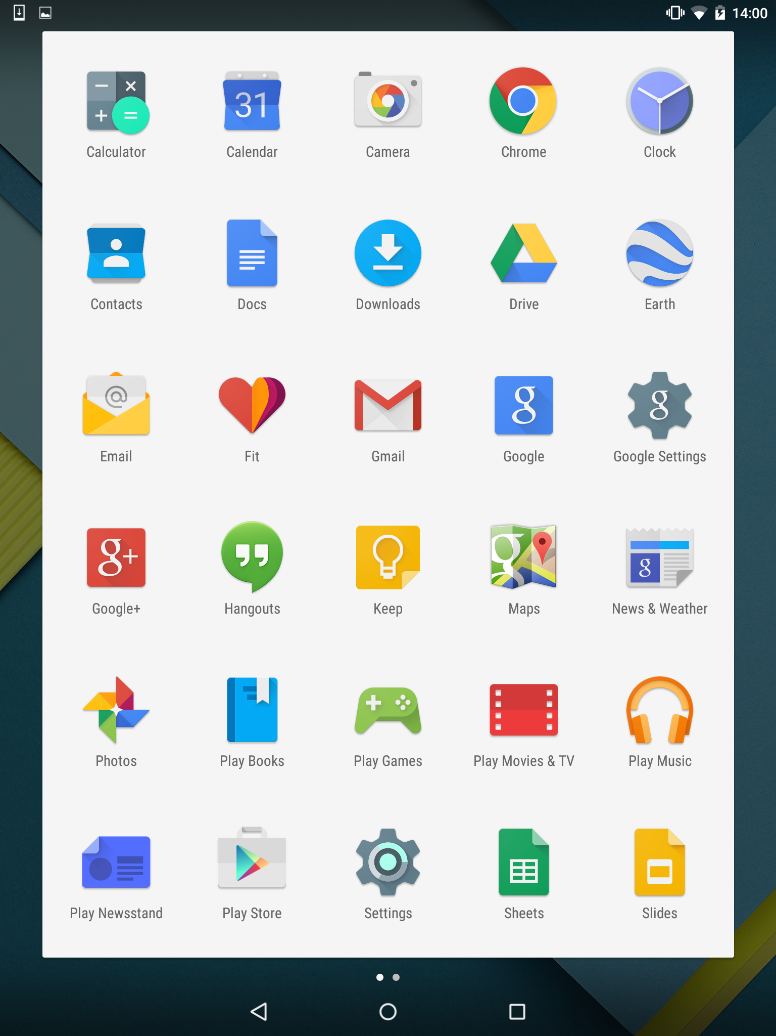

Scroll to the bottom of the Settings screen, and under the “System” section you will see “**About Tablet”. Tap this button.**

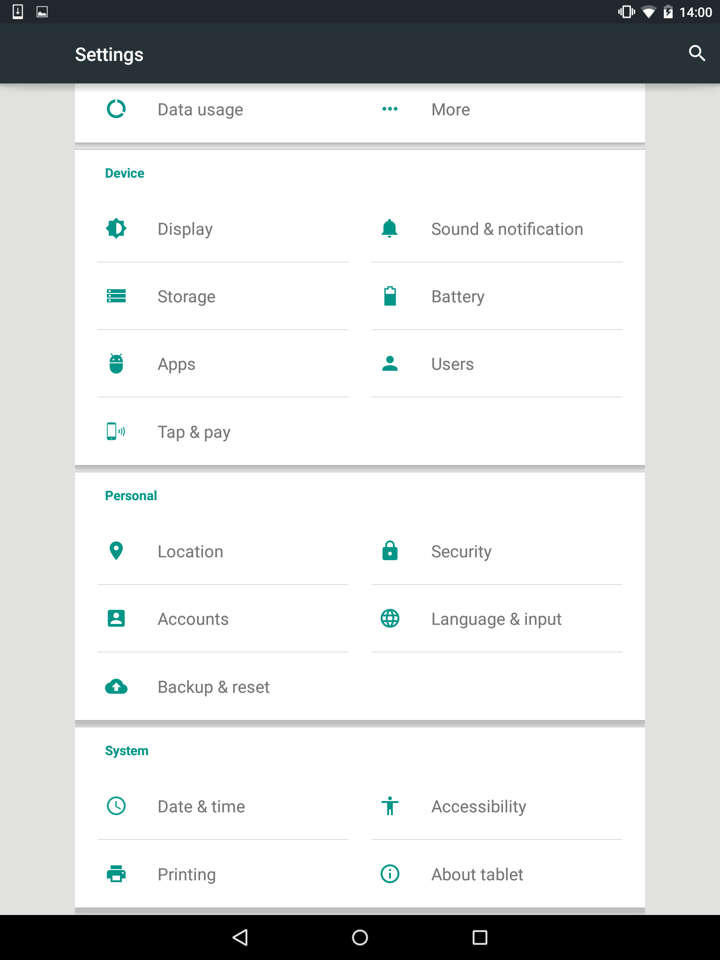

There should be a section in the next table entitled ‘Build Number’. Tap this around 7-8 times, and a prompt should then appear saying – **You are now a developer!**

Return to the main settings application page, and scroll to the bottom of the settings screen and under the System section you will see **Developer options.** Tap this button.

On the next screen, Tick the box next to:

* **Enable OEM unlock**
* **USB Debugging**

Enable OEM unlock – allows you to install the Core system onto the tablet.

USB Debugging – allows the tablet and the Computer to communicate to one another.

Tap the Home button (situated in the middle of the black bar at the bottom)

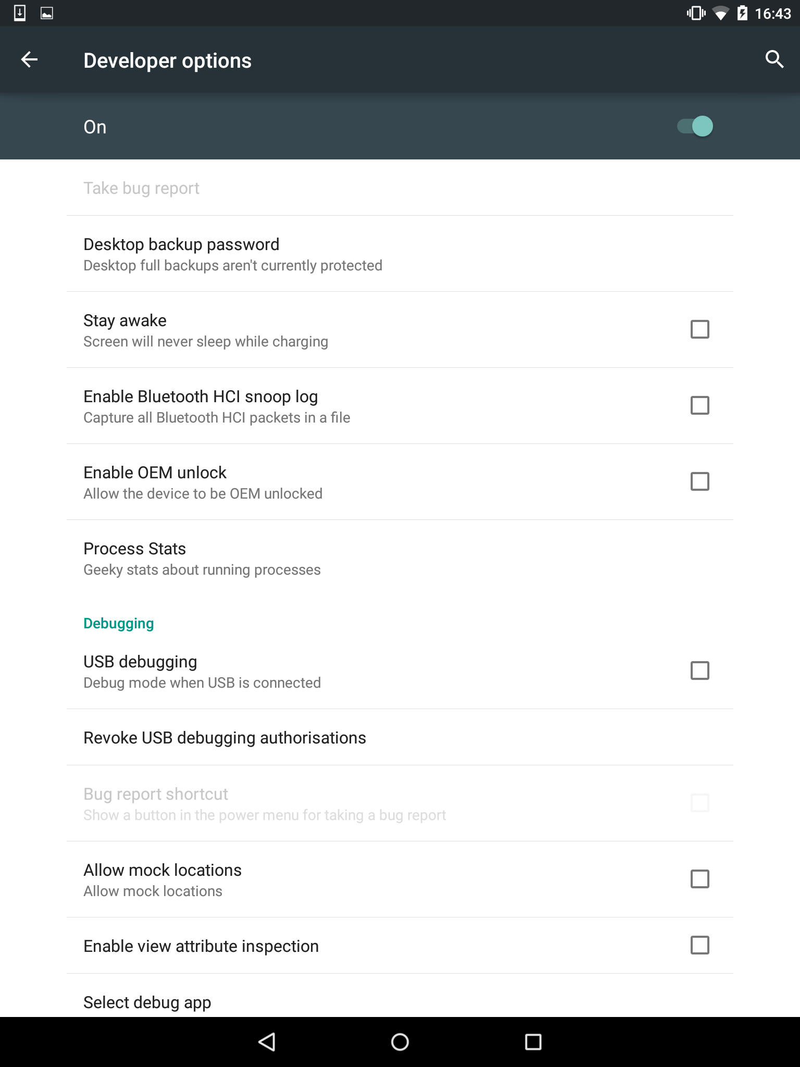

## Connect tablet to Computer via USB Cable

* 1. You should see a USB Debugging popup on screen – tap “OK”.

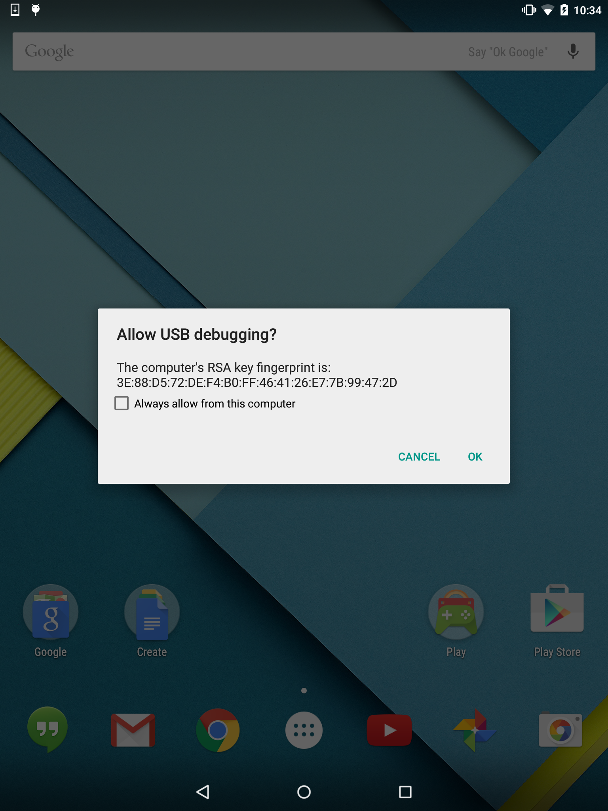

## Start Bootloader

* 1. Open Windows Explorer, and navigate to the **CoreTablets** folder.
  2. Open the **Stock Android Tablet [Retail]** folder

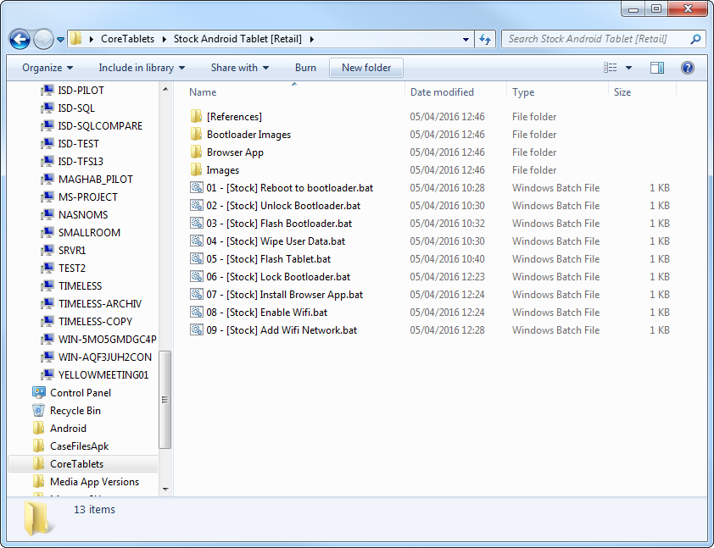

* 1. Double click on the **01 - [Stock] Reboot to bootloader.bat** file

The tablet will turn off and then start up with the bootloader

You should see “FASTBOOT”.

See image below:

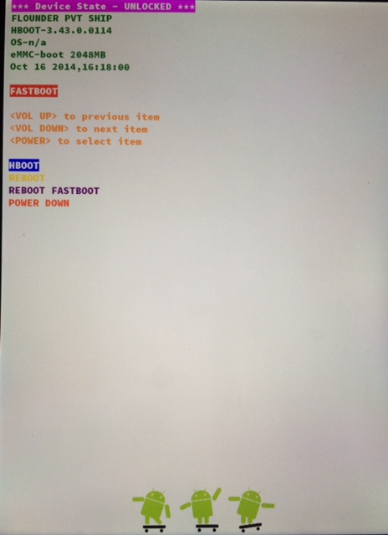

## Unlock Bootloader

In the **Initial Flash** folder:

* 1. Double click on the **02 - [Stock] Unlock Bootloader.bat** file
  2. The tablet should now change to a black screen, confirming yes / no if you want to unlock the bootloader.

Press the Volume Up button to confirm, wait for the device to return to the bootloader

## Flash Tablet

In the **Initial Flash** folder:

* 1. Double click **03 - [Stock] Flash Bootloader.bat** file, the window will alert you that it cannot find a core.zip file, this is nothing to worry about.
  2. Double click **04 - [Stock] Wipe User Data.bat** file
  3. Double click **05 - [Stock] Flash Tablet.bat** file, this may take some times, 60+ seconds to complete, you will see a small green bar on the device bootloader screen during this (top right hand side of the device). It can potentially hang here for a number of reasons outside of our control and in this instance the process should be restarted.

## Factory reset the tablet

The following steps are done on the physical tablet:

* 1. Press the power button to select **HBOOT**
  2. Use the volume up and down buttons to navigate to **FACTORY RESET**
  3. Press the power button to select **FACTORY RESET**
  4. Once tablet has powered on, double click **06 - [Stock] Lock Bootloader.bat,** once complete (you will see a small android icon and the device will eventually return to the bootloader menu) you can select **REBOOT** to restart the device

## Enable network settings

In the **Stock Android Tablet [Retail]** folder:

* 1. Double click the **07 - [Stock] Install Browser App.bat** file, the browser app will now be on the device.
  2. Double click **08 - [Stock] Enable Wifi.bat** file
  3. Double click **09 - [Stock] Add Wifi Network.bat** file, these can be updated and ran later if the wifi network password has changed, please see the end of the document for more information around that. This will add the prison wifi network to the device, ready for auto connection when in range.

# 

# Flashing existing Core Tablet with an updated version of Core system

## Navigate to Core Existing Tablet [Reflashing] Folder

* 1. Open Windows Explorer
  2. Navigate to **CoreTablets** folder
  3. Open **Core Existing Tablet [Reflashing]** Folder

## Open Files for Re Flashing tablet

In the **Core Existing Tablet [Reflashing]** folder:

* 1. Double click the **01 - [Core] Unlock Bootloader.bat** file, you will be taken to the bootloader menu and asked to press volume up in order to proceed, upon pressing volume up you will be reloaded back to the bootloader menu agains
  2. Double click the **02 - [Core] Flash Bootloader.bat** file, again an error is expected here (unable to find core.zip file) this is nothing to worry about.
  3. Double click the **03 - [Core] Wipe User Data.bat** file
  4. Double click the **04 - [Core] Flash Tablet.bat** file, again this is likely to take some time to complete.

## Factory reset the tablet

The following steps are done on the physical tablet:

* + Press the power button to select **HBOOT**
  + Use the volume up and down buttons to navigate to **FACTORY RESET**
  + Press the power button to select **FACTORY RESET**
  + Once tablet has powered on, double click **05 - [Core] Lock Bootloader.bat,** you will be returned to the bootloader menu after a small android icon is displayed on the screen, select **REBOOT** to load up the device.
  + Double click the **06 - [Core] Install Browser App.bat** file
  + Double click the **07 - [Core] Enable Wifi.bat** file
  + Double click the **08 - [Core] Add Wifi Network.bat** file

# The Process Concerning Tablets From New Manufacturers

|  |  |
| --- | --- |
| **Advantages** | **Challenges** |
| Samsung has open-sourced its kernel source code. | Samsung has many proprietary drivers for its hardware. |
|  | There is little to no existing documentation on compiling AOSP for tablet devices. |
|  | AOSP will be difficult to integrate with Samsung drivers and kernel space. |

In this instance, the target manufacturer is Samsung. This task is made challenging by a few factors:

# Future Steps

# Communication with Samsung

Dear Customer,   
  
Thank you for your continuous interest in our product.   
We have received your request through OSRC web site.   
  
This web site is intended to provide Open Source Software used in our product. Please accept our apology for not being able to handle your request up to your satisfaction.   
We can't confirm which defconfig files you should use for which chipsets (since we are only required to release opensource software to the customer.) but you may need to use defconfig file which is included in requested model and SW version's opensource software published at OSRC site.   
  
If you buy a tablet that contains Sanpdragon 400 chipset, then please send us new request for opensource software for your new tablet model and SW version (firmware version). In this way, you may get proper defconfig file of kernel for your model.   
  
Please, do not hesitate to contact us if you have any other questions regarding Open Source Software.   
  
Thank you.

# Appendix X: Samsung Region Codes for Firmware and Tablet Versions

SAMSUNG REGION CODES (AS IN “TABLET VERSIONT555**XX**U1AOD1”**)**

**BD** Cyprus, Greece  
**CP** Finland  
**DB**Vietnam  
**DC** Thailand  
**DD** India  
**DT** Australia  
**DX** Indonesia, Malaysia, Philippines, Singapore, Vietnam  
**DZ** Malaysia, Singapore  
**JA** South Africa  
**JC** Algeria, Morocco, Nigeria, South Africa, Tunisia  
**JP** Arabic  
**JR** Arabic  
**JV** Algeria, Egypt, Iran, Iraq, Kuwait, Morocco, Nigeria, Oman, Pakistan, Saudi Arabia, South Africa, Syria, Tunisia, Turkey  
**MT** Switzerland  
**XA** Austria, France, Germany, Italy, Netherlands, Switzerland, United Kingdom  
**XB** Denmark, Norway, Sweden  
**XC** Portugal, Spain  
**XD** Croatia, Czech, Hungary, Slovakia  
**XE** Bulgaria, Estonia, Kazakhstan, Latvia, Lithuania, Russia, Ukraine  
**XF** Bulgaria, Croatia, Romania  
**XW** France, Germany, Italy, Netherlands, Portugal, Spain, Turkey, United Kingdom  
**XX** Austria, Belgium, France, Germany, Hungary, Italy, Spain, United Kingdom  
**ZC** China, Hong Kong  
**ZH** Hong Kong  
**ZT** Taiwan

# References

<http://graemehill.ca/compiling-permissive-android-kernel/>